 

Madhuben & Bhanubhai Patel Institute of Technology

**(A constituent College of CVM University) New V. V. Nagar**

# INFORMATION TECHNOLOGY DEPARTMENT

## Mini Project Report on

***ONLINE QUIZ WEB APPLICATION***

## Submitted By

**Name of Student : Hardikkumar Bharatbhai Kangasiya**

**Enrolment Number : 12102080701031**

**Name of Student : Joshi Dhruvkumar Anilbhai**

**Enrolment Number : 12102080701023**

## Guided By

**Prof. Jimesh Rana**

# MINI PROJECT (102040601)

**A.Y. 2022-23 EVEN TERM**

 

# CERTIFICATE

This is to certify that the Mini Project Report submitted entitled **Online Quiz Web Application** has been carried out by **Hardikkumar Bharatbhai Kangasiya** (12102080701031) under guidance in partial fulfillment for the Degree of Bachelor of Engineering in Information Technology, 6th Semester of Madhuben and Bhanubhai Patel Institute of Technology, CVM University, New Vallabh Vidyanagar during the academic year 2023-24.

Prof. Jimesh Rana Prof. Jagruti Prajapati

Internal Guide Head of Department

 

# CERTIFICATE

This is to certify that the Mini Project Report submitted entitled **Online Quiz Web Application** has been carried out by **Joshi Dhruvkumar Anilbhai** (12102080701023) under guidance in partial fulfillment for the Degree of Bachelor of Engineering in Information Technology, 6th Semester of Madhuben and Bhanubhai Patel Institute of Technology, CVM University, New Vallabh Vidyanagar during the academic year 2023-24.

Prof. Jimesh Rana Prof. Jagruti Prajapati

Internal Guide Head of Department

# ACKNOWLEDGEMENTS

# I would like to express my sincere gratitude to Prof. Jimesh Rana for his invaluable guidance, unwavering support, and expert supervision throughout the development of this project. His insights, feedback, and encouragement have been instrumental in shaping the Online Quiz Application. I would also like to extend my heartfelt thanks to all the faculty members of the Department of Information Technology for their encouragement and support. Additionally, I am immensely grateful to my peers and friends for their assistance and constructive feedback during the course of this project. Their inputs have significantly contributed to the refinement and improvement of the Online Quiz Application. This project would not have been possible without the support and encouragement of all those mentioned above.

**Dhruv Joshi &**

**Hardik Kangasiya**

# ABSTRACT

The Online Quiz Application is a versatile web-based platform designed to streamline the process of administering quizzes in educational and professional settings. It offers features such as user registration, quiz category creation, real-time quiz sessions with timed responses, automated scoring, and detailed result analysis. Developed using React.js, Tailwind CSS, Django and sqlite3, the application ensures a responsive interface and data security. It caters to the growing demand for remote learning and assessment, providing an intuitive solution accessible across devices. By facilitating efficient quiz management and enhancing user engagement, the Online Quiz Application contributes to the advancement of online education and evaluation methodologies. Its scalability and user-centric design make it suitable for various educational institutions, corporate training programs, and online assessment initiatives, promising to improve learning outcomes and assessment processes in the digital era.

**Table of Content**

**Chapter Page No.**

|  |  |  |  |
| --- | --- | --- | --- |
|  |  |  |  |
| 1 | Introduction | |  |
|  | 1.1 | Problem Statement |  |
|  | 1.2 | Project summary |  |
|  | 1.3 | Aim and objective of project |  |
| 2 | System analysis | |  |
|  | 2.1 | Motivation |  |
|  | 2.2 | Brief Literature survey |  |
| 3 | Design: analysis, design methodology | |  |
|  | 3.1 | H/W and S/W requirement |  |
|  | 3.2 | Program/module specification |  |
|  | 3.3 | UML diagram |  |
| 4 | Implementation | |  |
|  | 4.1 | System flow |  |
|  | 4.3 | Results |  |
| 5 | Conclusion and Future work | |  |
| 6 | References | |  |

**Chapter - 1 Introduction**

1. **Problem Statement**
   * In traditional educational and professional settings, the process of administering quizzes often faces challenges related to logistics, time constraints, and resource allocation. Physical constraints such as limited space and time availability restrict the frequency and scale of quiz sessions, hindering the timely evaluation and feedback process. Additionally, manual grading procedures are labor-intensive and prone to errors, leading to delays in result dissemination and feedback provision. Furthermore, the transition to remote learning and assessment necessitates a robust and user-friendly platform to facilitate the administration and participation of quizzes online.
   * Thus, there is a pressing need for an efficient and scalable solution that addresses these challenges by providing a comprehensive online quiz application. This application should offer features such as user registration, quiz creation and management, real-time quiz sessions, automated scoring, and detailed result analysis. By overcoming the limitations of traditional quiz administration methods and leveraging the capabilities of modern web technologies, such an application can revolutionize the way quizzes are conducted, evaluated, and utilized for educational and professional purposes.

**1.2 Project Summary**

* + The Online Quiz Application project aims to develop a versatile web-based platform that revolutionizes the administration and participation of quizzes in educational and professional contexts. This application addresses the limitations of traditional quiz administration methods by offering a comprehensive set of features, including user registration, quiz creation and management, real-time quiz sessions, automated scoring, and detailed result analysis.
  + Developed using modern web technologies such as HTML5, CSS3, JavaScript, PHP, and MySQL, the application ensures a responsive interface, scalability, and robust data security. It caters to the growing demand for remote learning and assessment, providing an intuitive solution accessible across devices.
  + By streamlining the quiz administration process, enhancing user engagement, and facilitating timely evaluation and feedback provision, the Online Quiz Application promises to improve learning outcomes and assessment processes in educational institutions, corporate training programs, and online assessment initiatives. Its user-centric design and scalability make it suitable for various educational and professional contexts, positioning it as a valuable tool in the digital era.
  1. **Aim of a project**
* The aim of the Online Quiz Application is to provide a comprehensive and user-friendly platform for the efficient administration and participation of quizzes in educational and professional settings, addressing the challenges associated with traditional quiz administration methods and meeting the evolving needs of remote learning and assessment.
* The objectives of the Online Quiz Application converge on creating a user-friendly and efficient platform for administering quizzes in educational and professional environments. It aims to streamline user registration and authentication processes securely while empowering administrators to easily manage quiz creation and organization.
* Real-time quiz sessions with timed responses foster engagement, complemented by automated scoring mechanisms that provide immediate feedback. Detailed result analysis tools enable users to track performance and identify areas for improvement.
* Cross-device compatibility ensures accessibility, while robust security measures safeguard user data. Continuous updates based on feedback and technological advancements ensure the application remains relevant and effective.
* Scalable infrastructure supports growing user demands, while collaborative efforts promote widespread adoption across various sectors, positioning the Online Quiz Application as a valuable tool for modern assessment needs.

**CHAPTER - 2 SYSTEM ANALYSIS**

**2.1 Motivation**

* Behind the system analysis phase of the Online Quiz Application project lies in the recognition of the shortcomings and challenges associated with traditional quiz administration methods.
* Conventional approaches to conducting quizzes, whether in educational institutions or professional settings, often involve logistical constraints, time limitations, and manual grading processes.
* These constraints not only hinder the frequency and scalability of quiz sessions but also delay the provision of feedback to participants. Additionally, the shift towards remote learning and assessment further underscores the need for a modernized and efficient solution to facilitate quizzes online.
* By conducting a comprehensive system analysis, we aim to identify these challenges and opportunities to design and develop a robust online quiz platform that addresses the evolving needs of educational and professional assessment.

**2.2 Brief Literature Survey**

* A brief literature survey was conducted to understand the existing research and practices related to online quiz platforms and assessment methodologies.
* Various scholarly articles, research papers, and academic resources were reviewed to gain insights into the features, functionalities, and best practices employed in similar systems.
* The literature survey revealed that online quiz applications offer several advantages over traditional methods, including increased accessibility, flexibility, and scalability.
* Key features identified from the literature include user registration and authentication, quiz creation and management tools, real-time quiz sessions with timed responses, automated scoring mechanisms, and result analysis functionalities.
* Furthermore, the survey highlighted the importance of user-centric design, data security measures, and continuous improvement based on user feedback in the development of effective online quiz platforms. These findings informed the design and development approach adopted for the Online Quiz Application project, ensuring alignment with established best practices and addressing current challenges in the field of online assessment.

**CHAPTER -3 DESIGN : ANALYSIS, DESIGN METHODOLOGY**

* 1. **H/W and S/W Requirements**

The hardware and software requirements for the Online Quiz Application have been carefully analyzed to ensure optimal performance and compatibility across various environments.

* **Hardware Requirements:**
  + **Server:** A web server capable of running Django and Sqlite3, with sufficient processing power and storage capacity to handle concurrent user requests.
  + **Client Devices:** Any device with a modern web browser and internet connectivity, including desktop computers, laptops, tablets, and smart phones.
* **Software Requirements:**
  + **Operating System:** Compatible with Linux, Windows, or macOS for server deployment.
  + **Programming Languages:** Django for server-side scripting, React js and Tailwind Css for front-end development.
  + **Development Tools:** Code editor (e.g., Visual Studio Code ) and version control system (e.g., Git) for collaborative development.

**3.2 Program/Module Specification**

The Online Quiz Application comprises several modules, each serving a specific function to facilitate quiz administration and participation:

* **User Management Module:** Handles user registration, authentication, and profile management functionalities.
* **Quiz Management Module:** Allows administrators to create, edit, and organize quizzes into categories.
* **Quiz Session Module:** Facilitates real-time quiz sessions with timed responses and question navigation.
* **Scoring Module:** Automatically scores quiz responses and provides instant feedback to participants.
* **Result Analysis Module:** Generates detailed performance reports and analytics for administrators and participants.

Each module is designed to be modular and loosely coupled, allowing for easier maintenance, scalability, and future enhancements.

* 1. **UML Diagrams:**
* **Class Diagram :**

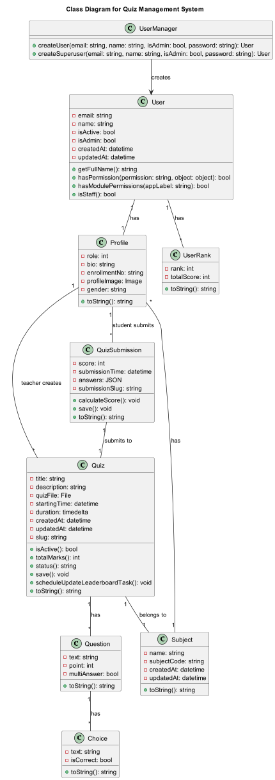

[Fig. 3.1 Class Diagram for online quiz application ]

**Chapter-4 Implementation**

**4.1 System Flow**

1. **Teacher Fuctionality :**

* Teacher Logs in to application
* Teacher can create subjects
* Teacher can edit subject details
* Delete Subject
* Results
* Student Profile

1. **Student Functionality**

* Student logs in to the application.
* Student selects a subject they want to take a quiz in.
* Student sees the list of quizzes available under the selected subject.
* Student selects a quiz to attempt.
* Student answers the questions in the quiz.
* Once done, student submits the quiz.
* Student receives feedback on the quiz (score, correct answers, etc.).

1. **Quiz Fuctionality**

* No one can copy the questions while attending the quiz.
* No one can Take the screenshots from the quiz
* All the questions and options are shuffled
* Quiz Created using Excel file
* Quiz Can be exported in the form of excel file
* Quiz questions can be edited while quiz in pending state
* Realtime quiz update

1. **Subject Fuctionality**

* Teacher Can create subjects
* Update subject details
* Delete whole subject
* Enroll Students using excel file

**4.2 Results**

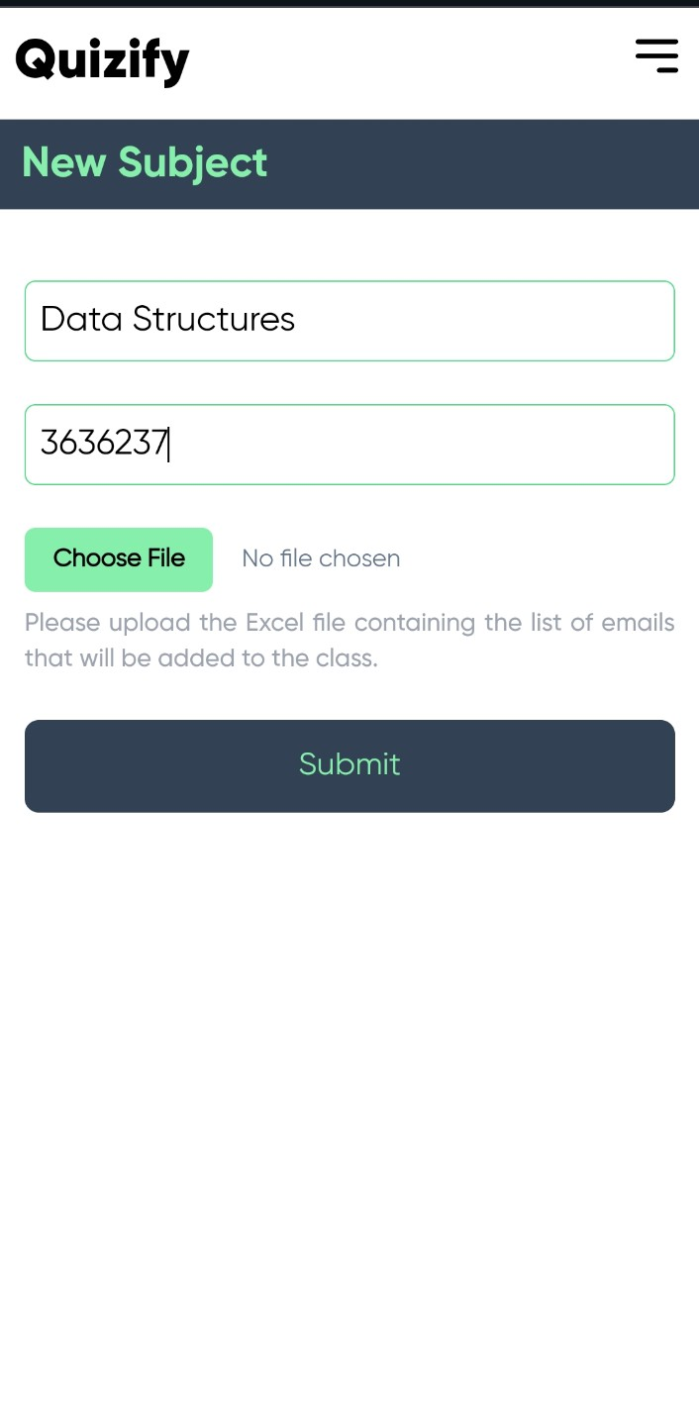





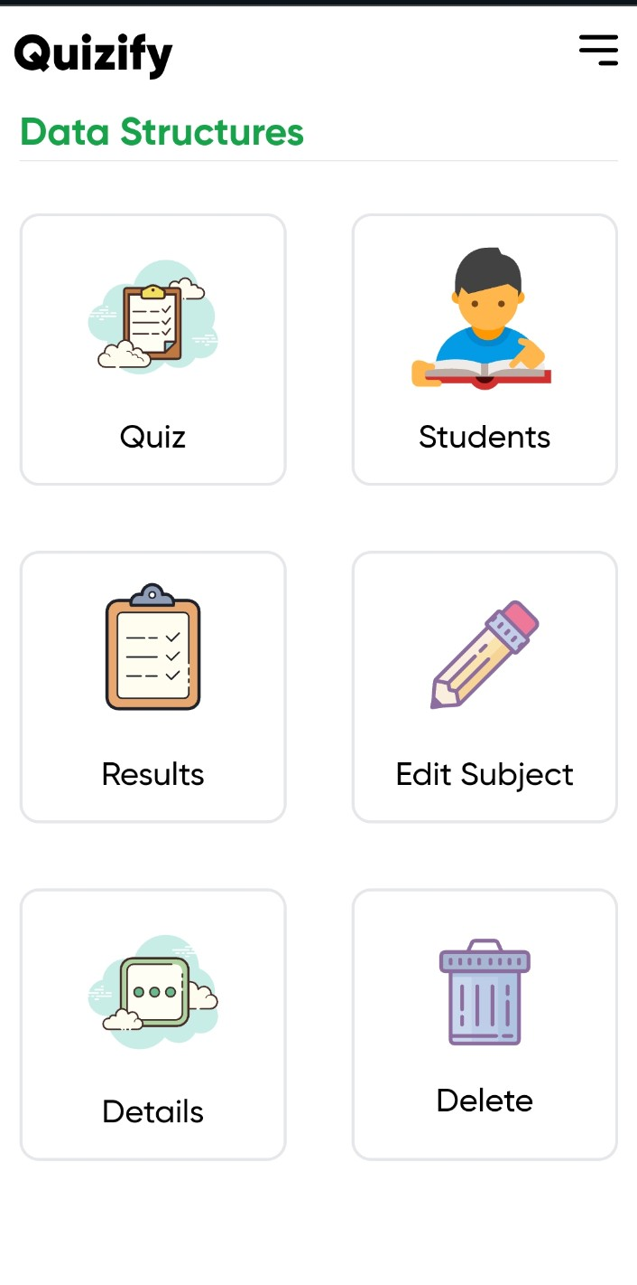



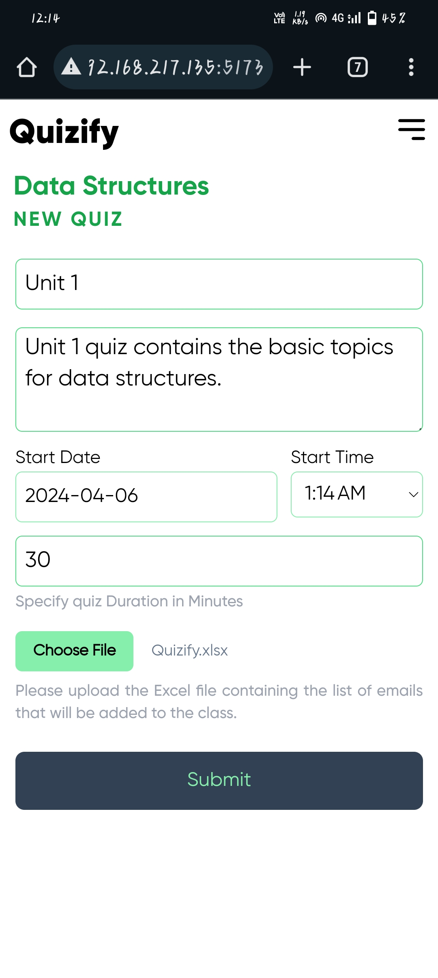



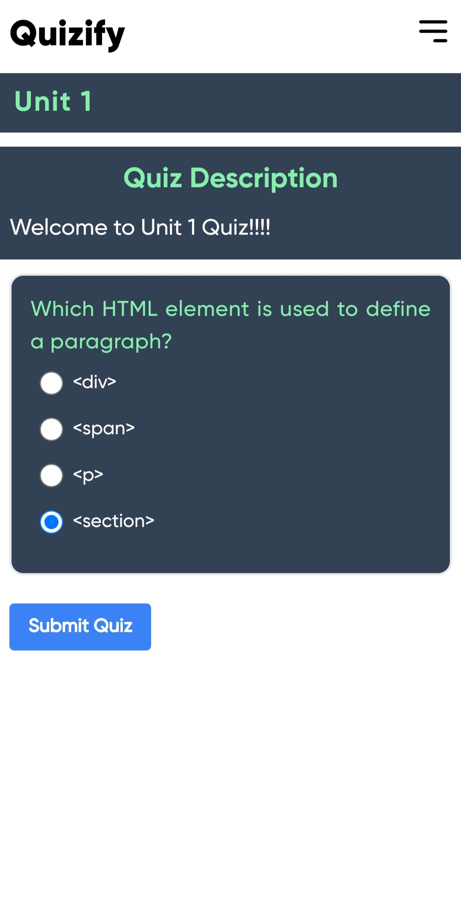

**CHAPTER-5 CONCLUSION & FUTURE WORK**

**Conclusion :**

In conclusion, the development of an online quiz application that allows teachers to create quizzes using Excel files and enables students to attend them represents a significant step forward in educational technology. This application streamlines the quiz creation process for educators and provides a convenient platform for students to engage with course material.

**Future Work :**

Moving forward, there are several areas for improvement and expansion in our online quiz application. One crucial aspect is the implementation of robust anti-cheating measures to ensure the integrity of the assessment process. This could involve the integration of proctoring software, advanced algorithms to detect suspicious behavior, or innovative methods to verify the identity of students taking the quiz.

Furthermore, expanding the functionality of the application to support a wider range of file formats for quiz creation, as well as integration with learning management systems (LMS), can enhance its usability and accessibility.

Continued collaboration with educators and students to gather feedback and insights will be essential for refining the application and ensuring it meets the evolving needs of the educational community.

**CHAPTER-6 REFERENCES**

1. edapp.com
2. quizlet.com
3. kahoot.com
4. flexiquiz.com
5. quizgame.com
6. fyrebox.com
7. papershala.com
8. stackoverflow.com
9. github.com
10. javatpoint.com
11. researchgate.net
12. scholerworks.calstate.edu
13. irjmets.com
14. realpython.com
15. react.dev
16. tailwindcss.com
17. npmjs.com
18. deadsimplechat.com
19. reactrouter.com
20. djangoproject.com
21. redis.io
22. docs.celery.dev
23. devdocs.io
24. vitejs.dev
25. remixicon.com
26. icons8.com
27. swiperjs.com
28. gsap.com